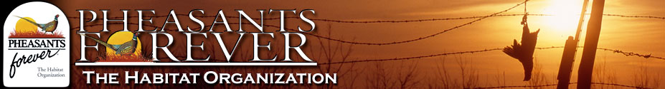

Greetings from the Morgan County chapter of Pheasants Forever!

We are a volunteer organization dedicated to improving wildlife habitat, especially for pheasants but the benefits extend from pollinator insects all the way up to mule deer. In addition to our habitat work, we also help provide places to hunt in Morgan County. Our chapter acts as the Walk In Access contractor (Morgan County) for Colorado Parks and Wildlife, opening up over 10,900 acres for public hunting. This is our early scouting report for the 2025 hunting season.

The walk in access parcels in Morgan County are located in two groups, one in northeast Morgan County plus some parcels close by in Weld County and the other grouping in southeast Morgan County plus some parcels close by in southeast Washington County.

The parcels in the northeast Morgan County area are native pastures, Conservation Reserve Program (CRP) lands (or recently expired) and dryland farms. Game you might encounter includes mourning and eurasian collared dove, limited pheasant population, and for big game hunters holding the proper unit license, mule deer, the occasional whitetail, and pronghorn antelope. While checking the WIA parcel signs in August, we saw scattered doves all through the area. After the native sunflowers ripen and the millet crops are swathed in September, the dove will concentrate on these food sources. This year, we had late summer rains that have filled water sources across northeast Morgan County, so dove have a variety of locations to get water. For big game hunters, remember, the plains deer populations are considerably lower than the deer herds west of I-25, so adjust your expectations accordingly.

The parcels in the southeast Morgan County area are mostly dryland farm fields with several windbreaks and some native pastures. Game you might encounter includes mourning and eurasian collared dove, pheasant, and for big game hunters holding the proper unit license, whitetail and mule deer, and limited pronghorn antelope. While checking the WIA parcel signs in August, we saw scattered doves all through the area. After the native sunflowers ripen and the millet crops are swathed in September, the dove will concentrate on these food sources. Hunting near the windbreaks can be good at times. Southeast Morgan County had good rains in late summer and crops as well as native vegetation food sources are just now ripening, so dove have a variety of locations to feed and roost. For big game hunters, remember, the plains deer populations are considerably lower than the deer herds west of I-25, so adjust your expectations accordingly.

Check back in late October for our Morgan County pheasant and goose forecast.

